Lutheran Church of
the Good Shepherd

SUNDAY OF THE PASSION
April 2, 2023
Entrance to Holy Week

– GATHERING –

The bell tolls at 10:40 a.m. inviting us to gather as the people of God.
Today we gather outside on the church steps, weather permitting.

PROCLAMATION OF THE ENTRANCE INTO JERUSALEM
Pastor: Hear from the Gospel according to Matthew, Chapter 21, verses 28-40, how our Lord Jesus entered Jerusalem.
ALL: Glory to you, O Lord.
Jesus enters Jerusalem
¹When they had come near Jerusalem and had reached Bethphage, at the Mount of Olives, Jesus sent two disciples, ²saying to them, “Go into the village ahead of you, and immediately you will find a donkey tied, and a colt with her; untie them and bring them to me. ³If anyone says anything to you, just say this, ‘The Lord needs them.’ And he will send them immediately.” ⁴This took place to fulfill what had been spoken through the prophet, saying,
⁵“Tell the daughter of Zion,
Look, your king is coming to you,
humble, and mounted on a donkey,
and on a colt, the foal of a donkey.”
⁶The disciples went and did as Jesus had directed them; ⁷they brought the donkey and the colt, and put their cloaks on them, and he sat on them. ⁸A very large crowd spread their cloaks on the road, and others cut branches from the trees and spread them on the road. ⁹The crowds that went ahead of him and that followed were shouting,
“Hosanna to the Son of David!
Blessed is the one who comes in the name of the Lord!
Hosanna in the highest heaven!”
¹⁰When he entered Jerusalem, the whole city was in turmoil, asking, “Who is this?” ¹¹The crowds were saying, “This is the prophet Jesus from Nazareth in Galilee.”

Leader: Hosanna to the Son of David!
ALL: Hosanna in the highest!
Blessed is the One who comes in the name of the Lord.
Hosanna in the highest!

ENTRANCE SONG We sing as we enter the sanctuary.
“All glory, laud, and honor” (ELW, p. 257, #344)

PRAYER OF THE DAY

Pastor: Everlasting God, in your endless love for the human race you sent our Lord Jesus Christ to take on our nature and to suffer death on the cross. In your mercy enable us to share in his obedience to your will and in the glorious victory of his resurrection, who lives and reigns with you and the Holy Spirit, one God, now and forever.

ALL: Amen.

Please be seated

– WORD –

THE PASSION OF JESUS, THE CHRIST ACCORDING TO MATTHEW

Matthew 27:11-54

In fulfillment of scripture and obedience to God’s will, Jesus goes to the cross so that a new covenant in his blood may bring forgiveness of sins. Even the soldiers who crucify him recognize him to be the Son of God.

¹¹Now Jesus stood before the governor; and the governor asked him, “Are you the King of the Jews?” Jesus said, “You say so.” ¹²But when he was accused by the chief priests and elders, he did not answer. ¹³Then Pilate said to him, “Do you not hear how many accusations they make against you?” ¹⁴But he gave him no answer, not even to a single charge, so that the governor was greatly amazed.
¹⁵Now at the festival the governor was accustomed to release a prisoner for the crowd, anyone whom they wanted. ¹⁶At that time they had a notorious prisoner, called Jesus Barabbas. ¹⁷So after they had gathered, Pilate said to them, “Whom do you want me to release for you, Jesus Barabbas or Jesus who is called the Messiah?” ¹⁸For he realized that it was out of jealousy that they had handed him over. ¹⁹While he was sitting on the judgment seat, his wife sent word to him, “Have nothing to do with that innocent man, for today I have suffered a great deal because of a dream about him.” ²⁰Now the chief priests and the elders persuaded the crowds to ask for Barabbas and to have Jesus killed. ²¹The governor again said to them, “Which of the two do you want me to release for you?” And they said, “Barabbas.” ²²Pilate said to them, “Then what should I do with Jesus who is called the Messiah?” All of them said, “Let him be crucified!” ²³Then he asked, “Why, what evil has he done?” But they shouted all the more, “Let him be crucified!”
²⁴So when Pilate saw that he could do nothing, but rather that a riot was beginning, he took some water and washed his hands before the crowd, saying, “I am innocent of this man’s blood; see to it yourselves.” ²⁵Then the people as a whole answered, “His blood be on us and on our children!” ²⁶So he released Barabbas for them; and after flogging Jesus, he handed him over to be crucified.
²⁷Then the soldiers of the governor took Jesus into the governor’s headquarters, and they gathered the whole cohort around him. ²⁸They stripped him and put a scarlet robe on him, ²⁹and after twisting some thorns into a crown, they put it on his head. They put a reed in his right hand and knelt before him and mocked him, saying, “Hail, King of the Jews!” ³⁰They spat on him, and took the reed and struck him on the head. ³¹After mocking him, they stripped him of the robe and put his own clothes on him. Then they led him away to crucify him.
³²As they went out, they came upon a man from Cyrene named Simon; they compelled this man to carry his cross. ³³And when they came to a place called Golgotha (which means Place of a Skull), ³⁴they offered him wine to drink, mixed with gall; but when he tasted it, he would not drink it. ³⁵And when they had crucified him, they divided his clothes among themselves by casting lots; ³⁶then they sat down there and kept watch over him. ³⁷Over his head they put the charge against him, which read, “This is Jesus, the King of the Jews.”
³⁸Then two bandits were crucified with him, one on his right and one on his left. ³⁹Those who passed by derided him, shaking their heads ⁴⁰and saying, “You who would destroy the temple and build it in three days, save yourself! If you are the Son of God, come down from the cross.” ⁴¹In the same way the chief priests also, along with the scribes and elders, were mocking him, saying, ⁴²“He saved others; he cannot save himself. He is the King of Israel; let him come down from the cross now, and we will believe in him. ⁴³He trusts in God; let God deliver him now, if he wants to; for he said, ‘I am God’s Son.’ ” ⁴⁴The bandits who were crucified with him also taunted him in the same way.
⁴⁵From noon on, darkness came over the whole land until three in the afternoon. ⁴⁶And about three o’clock Jesus cried with a loud voice, “Eli, Eli, lema sabachthani?” that is, “My God, my God, why have you forsaken me?” ⁴⁷When some of the bystanders heard it, they said, “This man is calling for Elijah.” ⁴⁸At once one of them ran and got a sponge, filled it with sour wine, put it on a stick, and gave it to him to drink. ⁴⁹But the others said, “Wait, let us see whether Elijah will come to save him.” ⁵⁰Then Jesus cried again with a loud voice and breathed his last. ⁵¹At that moment the curtain of the temple was torn in two, from top to bottom. The earth shook, and the rocks were split. ⁵²The tombs also were opened, and many bodies of the saints who had fallen asleep were raised. ⁵³After his resurrection they came out of the tombs and entered the holy city and appeared to many. ⁵⁴Now when the centurion and those with him, who were keeping watch over Jesus, saw the earthquake and what took place, they were terrified and said, “Truly this man was God’s Son!”

Here ends the Passion of Jesus, the Christ.
All: Praise to you, O Christ.

HYMN OF THE DAY

“Jesus, I will ponder now” (ELW 345)

MESSAGE

SHARING OF THE PEACE

ENLARGING THE TABLE

OFFERING PRAYER
Leader: Generous God, you feed us with the harvest of the land, and you provide for our every need. Receive our gifts of money, imagination, and labor, and transform them into a feast that welcomes all, in Jesus Christ, our host and our guest.
ALL: Amen.

Reprinted under OneLicense.net A-713084

Holy Communion

Beloved of God,
we are invited to come and gather at the table of love and liberation,
to feast on the dreams of God,
to be nourished by but a taste of what God desires to do among us.
God calls us from halls of power,
From shelters and the streets;
God calls us from classrooms and pulpits.
God calls us as we are, from wherever we are,
to come and be in solidarity with Christ,
who lives and loves lavishly and relentlessly.

Come, and follow Christ on paths of uncertainty,
taking risks for one another,
calling down unjust power from its throne
and lifting up the lowly, the impoverished,
the burdened. To answer the call of Christ is to find ourselves
And to embrace new possibilities of healing, of connection,
of freedom from all that destroys. When these are the desires of our hearts,
we open ourselves to God. Blessed are those, Jesus said, who hunger and thirst for righteousness,
for they will be filled. And so let us come to the table, expectant, eager, open to tasting the rich blessings of heaven
born from unexpected places, and people, and experiences.
In this meal, we remember the life, death, and resurrection of the One who still takes on flesh among us today.
On the night he would be arrested, Jesus gathered his friends and companions.
In the midst of a tense and dangerous time, they sat down for a meal together.
And as they did so, Jesus took bread, gave thanks to God, broke the bread and shared it with his disciples saying,
“Take, eat; this is my body which is given for you. Do this in remembrance of me.”
When the supper was over, he also took the cup, gave thanks to God, and shared it with his disciples, saying,
“Drink from this, all of you; this is the cup of the new covenant. Do this, as often as you drink it,
in remembrance of me.”
And so we pray,
Come Holy Spirit, Breath of God, Renewer of life, Bless these gifts and all who gather here, that we might be transformed in our remembrance of your radical love, your eternal embrace, and your grace that makes all things news.
For the sake of our shared lives, the life of this land on which we live, and the lives of those yet to come,
nourish us and renew our hope that soon Christ may rise again among us.
The Lord be with you.
And also with you
Open your hearts to the One who is Love
We open our hearts to you, O God
Let us give thanks to God, who gives us courage
To the One who calls us to lives of service, we give thanks and praise
From our beginning, you shaped us to live in service to one another and all the earth. You set us
in the garden to co-create life with you. You surrounded us with creatures and creations that
depend on our care. Our destinies have always been wrapped up in one another – our individual
well-being bound to the well-being of all.

Therefore we join our voices with your people on earth and all the company of the heavens,
singing praise to you,

Holy, Holy, Holy Lord
God of power and might
Heaven and earth are full of your glory
Hosanna in the highest

Gracious One, we struggle with spirits of fear and greed that tempt us away from your original
plan for us. We excuse ourselves from responsibilities to our neighbors. We struggle to believe
we have anything to offer to the whole. And at times we knowingly do harm to others for the
sake of our own gain.

THE LORD’S PRAYER

ALL:

Our Father, who art in heaven, hallowed be thy name,

thy kingdom come, thy will be done, on earth as it is in heaven.

Give us this day our daily bread;

and forgive us our trespasses, as we forgive those who trespass against us;

and lead us not into temptation, but deliver us from evil.

For thine is the kingdom, and the power, and the glory, forever and ever. Amen.

INVITATION TO COMMUNION

Pastor: Christ has prepared the feast. Come to the table where all are welcomed home.

THE DISTRIBUTION OF THE MEAL

At Good Shepherd, we practice the radical hospitality of Jesus. Everyone is Welcome to this Grace.

WE SING DURING COMMUNION

“Lamb of God” #336

PRAYER AFTER COMMUNION

Leader: Tender and merciful one, at your feast, you fed us who brought nothing, turning our emptiness into joy. Filled with your abundant grace, send us now to be ministers of reconciliation, mending broken hearts, working for justice, and striving for peace among all people, in the name of Jesus Christ.

ALL: Amen.

BLESSING

Pastor: God, who fills the creation with abundance, Christ, who spreads his arms in forgiveness, Holy Spirit, who draws ever near to us, ☩ bless you and bring you to life everlasting.

ALL: Amen.

ANNOUNCEMENTS

DISMISSAL

Leader: Go in peace. Remember the poor.

ALL: Thanks be to God.

You are invited to Hospitality in the Soul Café next door.
If you would like to offer any items for coffee hour please call the office and let us know.

Presiding & Preaching: Rev. Juan Carlos Ruiz

Ministers of Music: Matthew Nielson

Hospitality: Good Shepherd

THIS WEEK
MAUNDY THURSDAY: Worship @ 8pm
GOOD FRIDAY: Sanctuary Open for Prayer 11am to 3pm Way of the Cross; Worship @ 7pm
SEDER Saturday 3:30 PM

RESURRECTION SUNDAY: Worship @ 12 noon
Children’s Egg Hunt follows worship
FEASTING

Holy Week at Good Shepherd

The palms we raised at the beginning are the ones that are burnt and used as a sign of our conversion on Ash Wednesday. With the sign of the cross, we are marked with ashes on our foreheads. We are branded with that sign of defeat, of death, and under that sign, we live our lives invoking God’s heart of mercy upon us as we give ourselves over in transforming our world. Here at Good Shepherd, we curate experiences where we deepen our belief in the dignity of all as children of God and renew our covenant to treat each other as brothers and sisters, actively engaging the world as we copartner in creating spaces where we can all breathe more freely.

The traditional disciplines of praying, fasting, and caring for the poor have been translated into the works of mercy for the last forty days as we enter the passion of our Lord and live into the resurrected spirit of our God. We, as a community church, have many opportunities to ground ourselves in prayer as we walk together, recognizing the sacred in our common humanity, granting us eyes to see how God sees us, and acting accordingly.

It is this eyesight, freely granted in prayer, that leads us to fast from what harms our relationships to one another and God in our world. A fasting that lifts the yoke of oppression and any violence that diminishes humanity, who is God’s presence, in the other. A fasting that identifies the many ways we replace God in our lives as we erect altars to our egos or protect our self-serving agendas that exclude others. Fasting leads us to acknowledge our interdependence and ultimately our reliance on God’s providence as we surrender ourselves to God’s mercy. Knowing God’s mercy personally leads us to be compassionate. As we walk the way of discipleship, we are called individually and live out that calling in the communities that we are part of.

Here, at Good Shepherd, we are inviting you to walk with us during this Holy Week as we enter the passion of our world and live in the power of the resurrection that stretches our imaginations to socialize hope and humanize our struggles.

Happy Holy Week!

Rev. Juan Carlos Ruiz

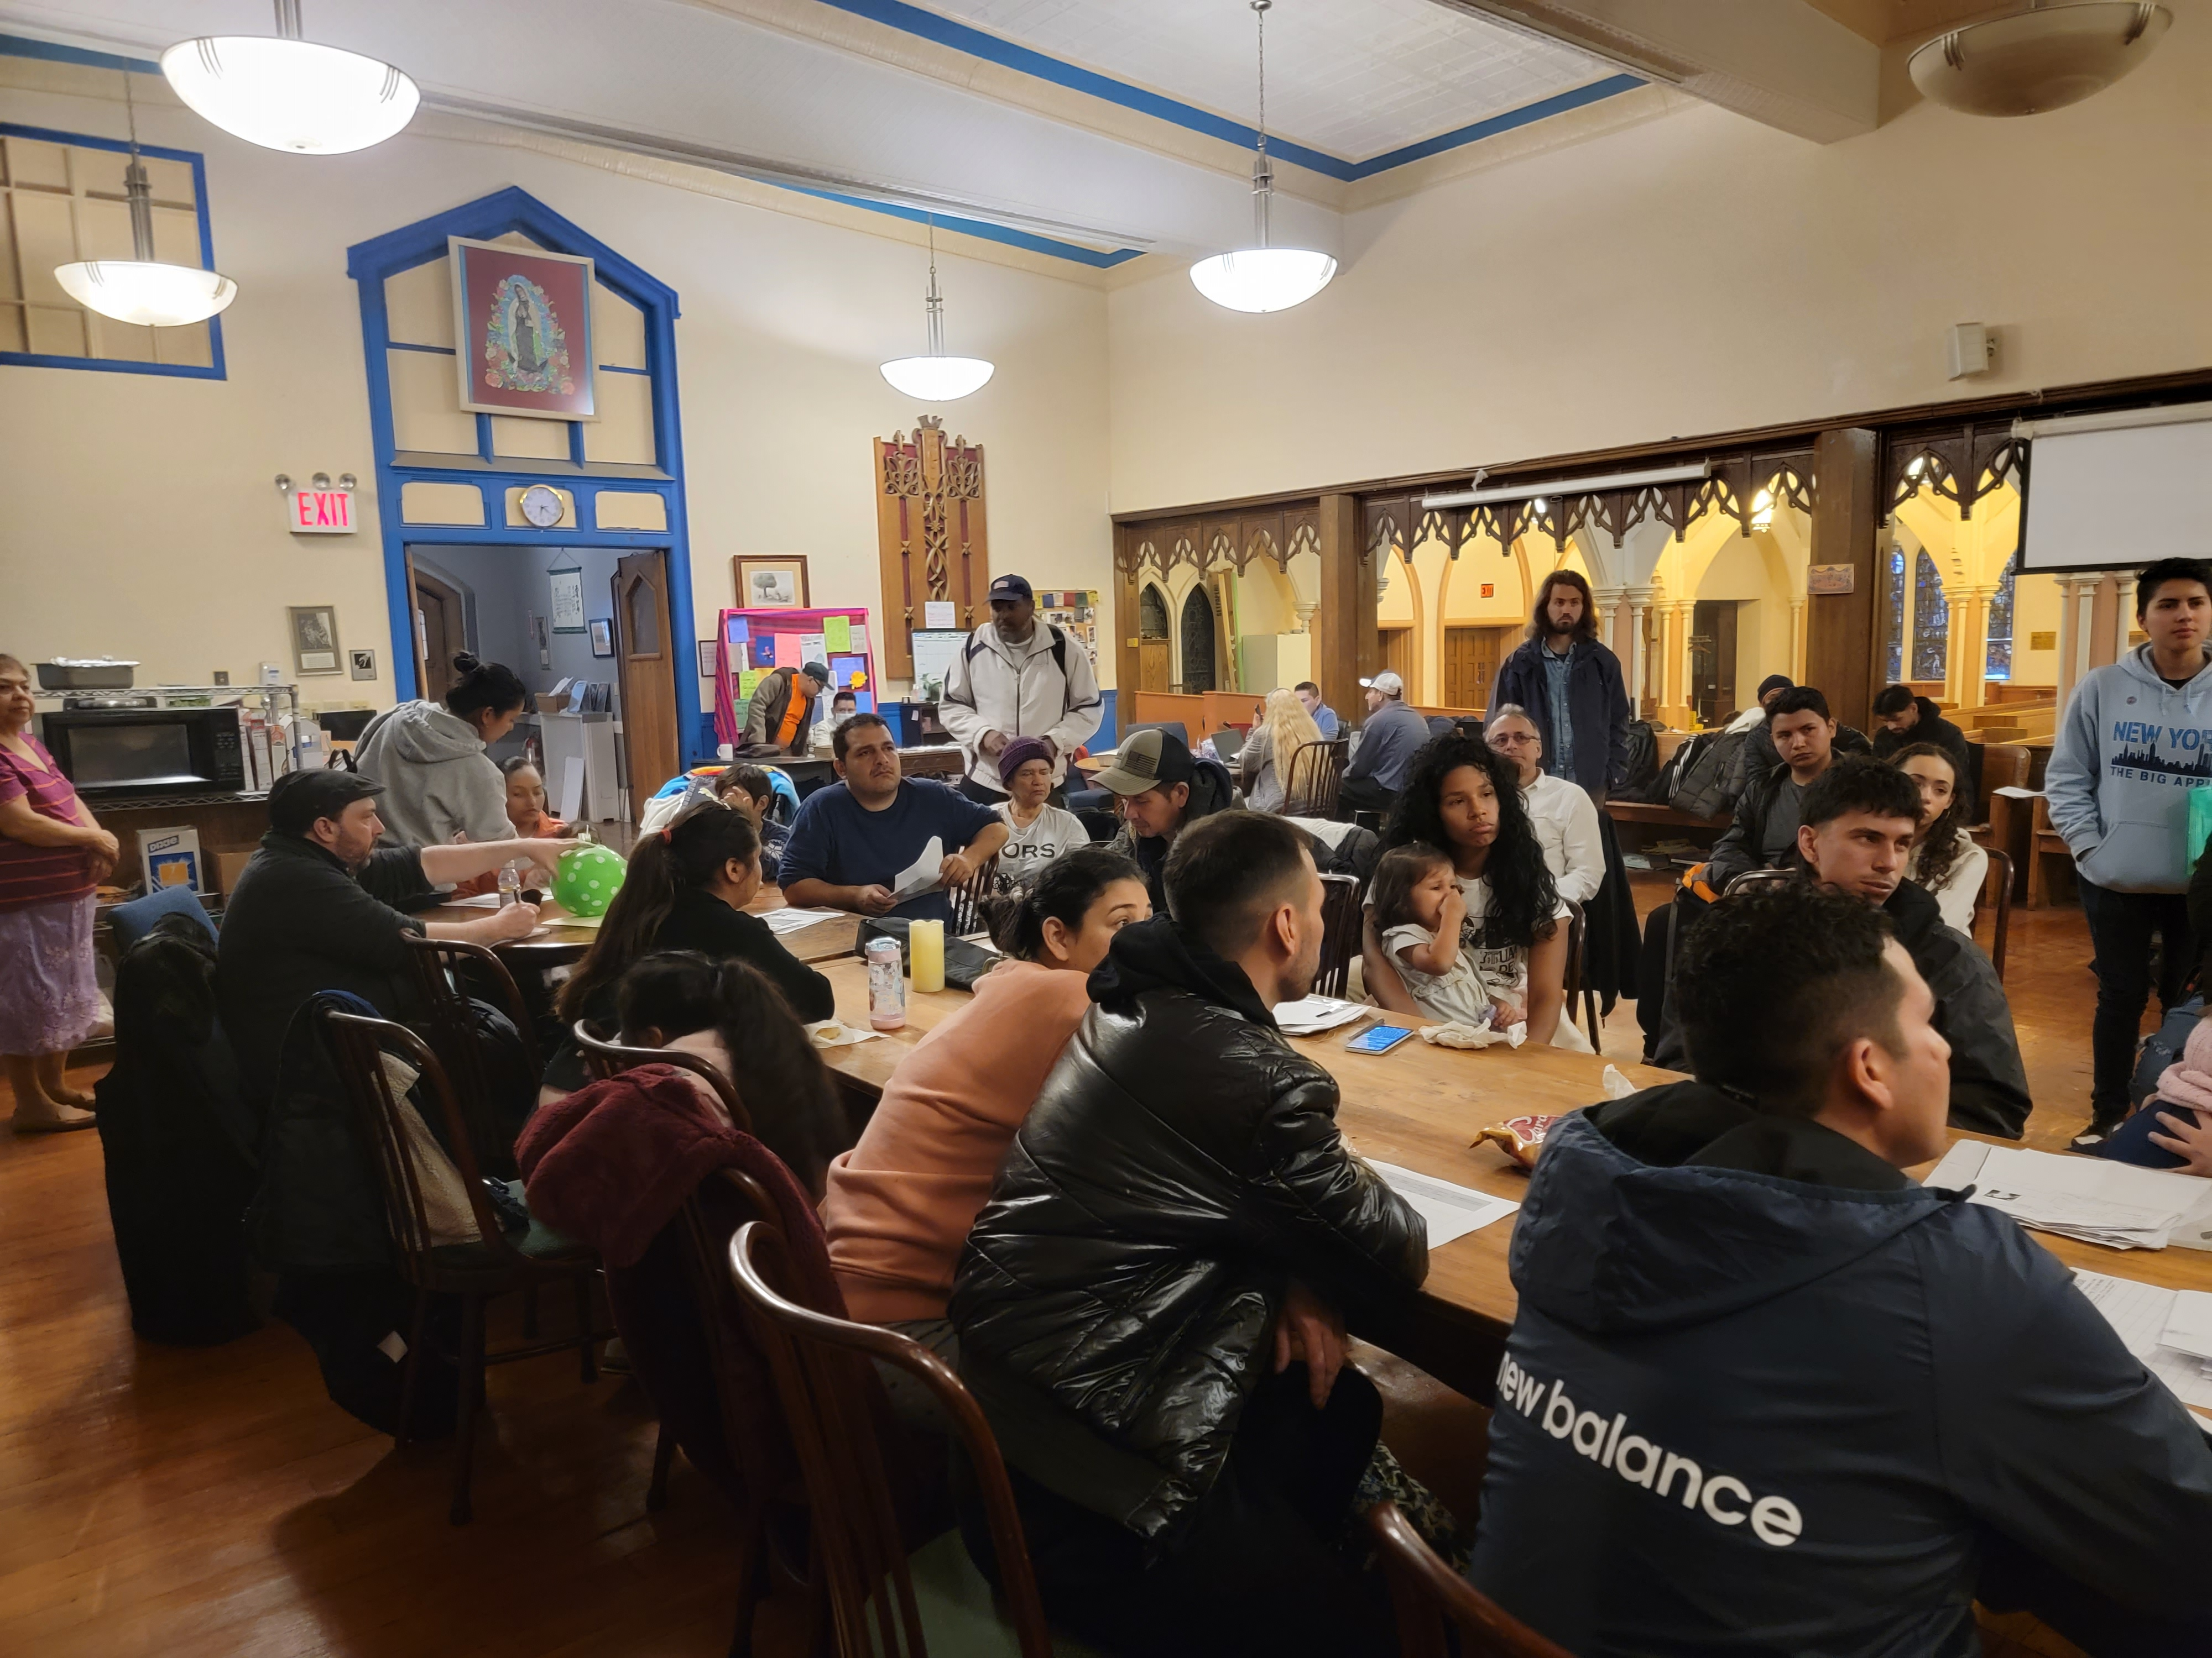

We continue to respond to our neighbor in our midst. Thank you for making this possible.

To learn more about the mission at Good Shepherd and subscribe to
e-news community,
visit: www.goodshepherdbayridge.space
call: 718-745-8520
Keep Up with the Good Shepherd Community Online!
Church Website: www.goodshepherdbayridge.space

